Welcome to MedWiz Specialty Pharmacy where you no longer have to worry about month-to-month refills or picking up your medications. Medications will be pre-packaged and delivered right to your home!
Here’s what will happen next:
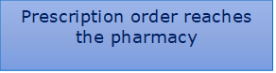

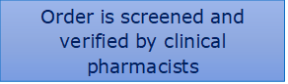

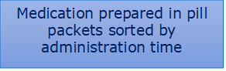

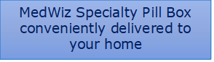

Make sure to save our number so you don’t miss any calls:
630-580-1700

